**Walchand College Of Engineering, Sangli**

**Department of Computer Science and Engineering**

**Subject: C&NS Lab**

**Batch: B4**

**Name: Gayatri Sopan Gade PRN:2020BTECS00210**

**Assignment 1**

**Title:** Implement the Ceasar cipher.

**Introduction:**

The Caesar Cipher technique is one of the earliest and simplest methods of encryption technique. It’s simply a type of substitution cipher, i.e., each letter of a given text is replaced by a letter with a fixed number of positions down the alphabet. For example with a shift of 1, A would be replaced by B, B would become C, and so on. The method is apparently named after Julius Caesar

**Algorithm:**

* Traverse the given text one character at a time .
* For each character, transform the given character as per the rule, depending on whether we’re encrypting or decrypting the text.
* Return the new string generated.

**Encryption**: (Plaintext + Key)mod 26

**Decryption**: (CipherText-Key)mod 26

**Example:**

Text : ABCDEFGHIJKLMNOPQRSTUVWXYZ

Key: 23

Cipher: XYZABCDEFGHIJKLMNOPQRSTUVW

Code :

Link: <https://github.com/gayatrig21/Cryptology-practicals/tree/Assignment-1>

Screenshots:

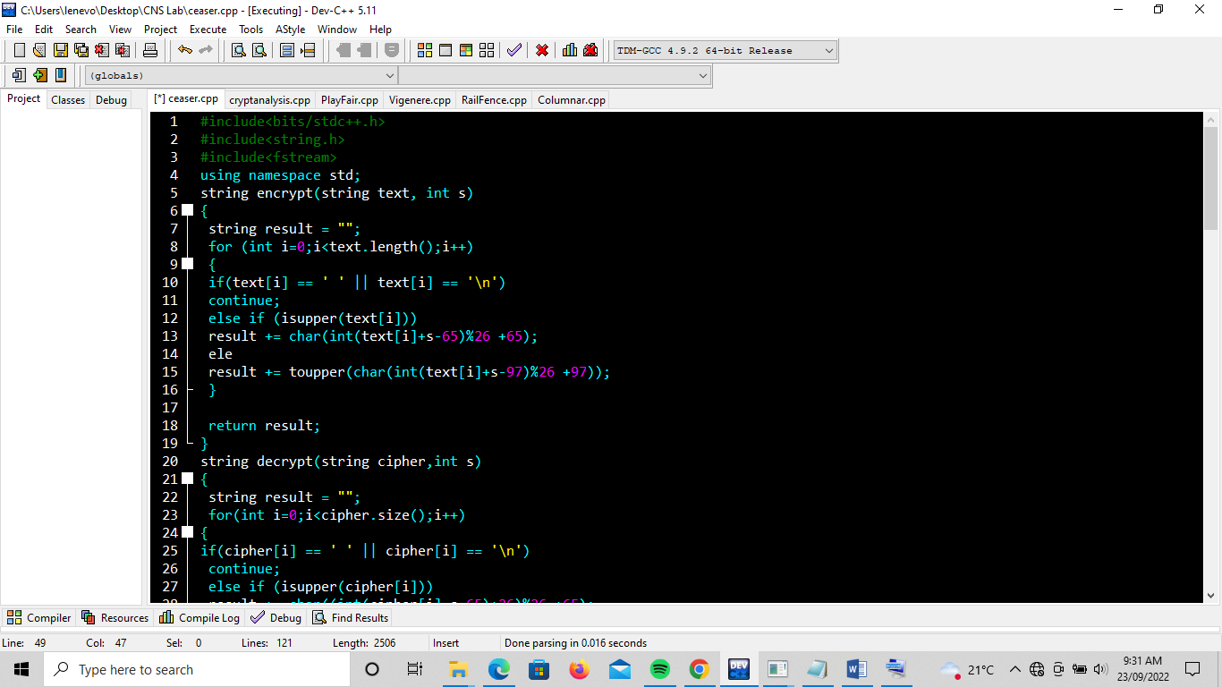

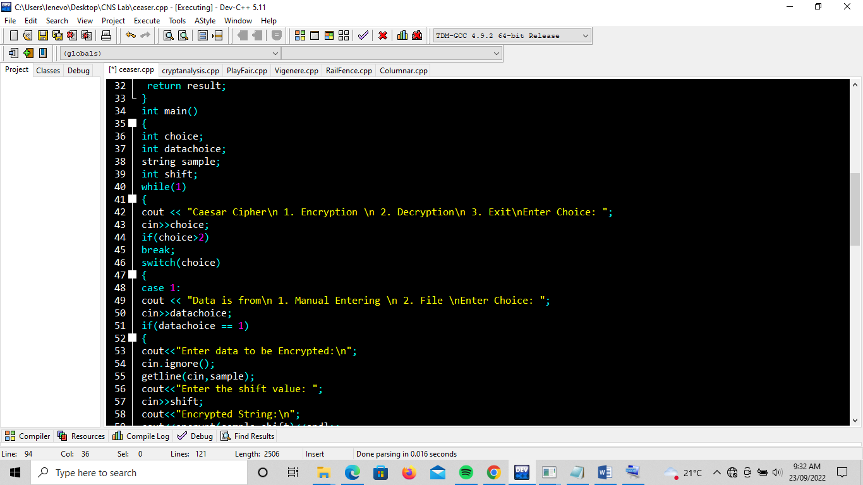

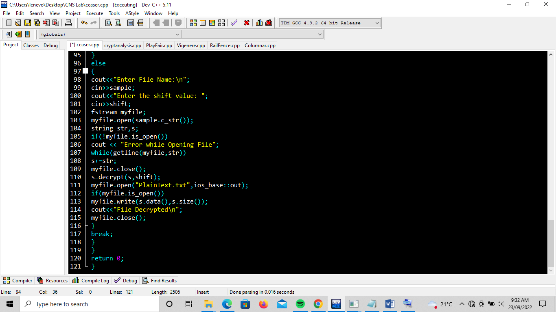

Output:

